G17.07 Sen Fang/Wirth

S4650134_Sen Fang

WP Site Assignment Documentation

Web Development and CMS

Contents

Site Map 1

Wire Frame 2

Purpose 3

Target of Audience 3

# Site Map

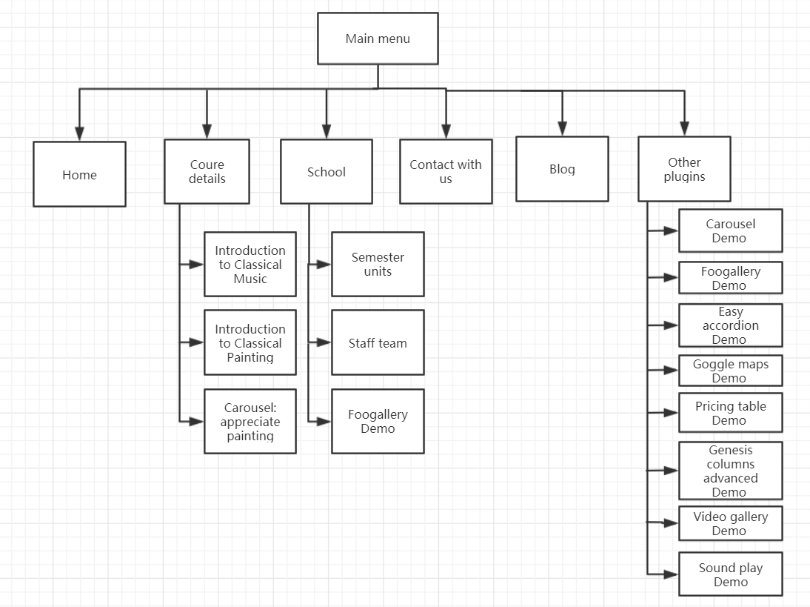

# 

# Wire Frame

Include Wireframes for about 5 of your web pages (no need to show any more). Although the screen shots below a re the same yours will will be different for each differerent page.

1.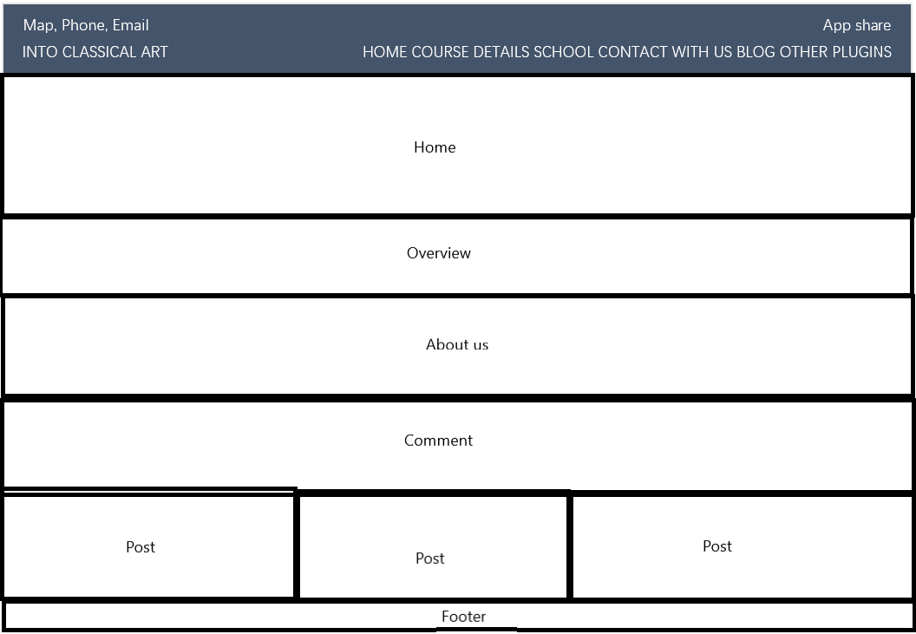2.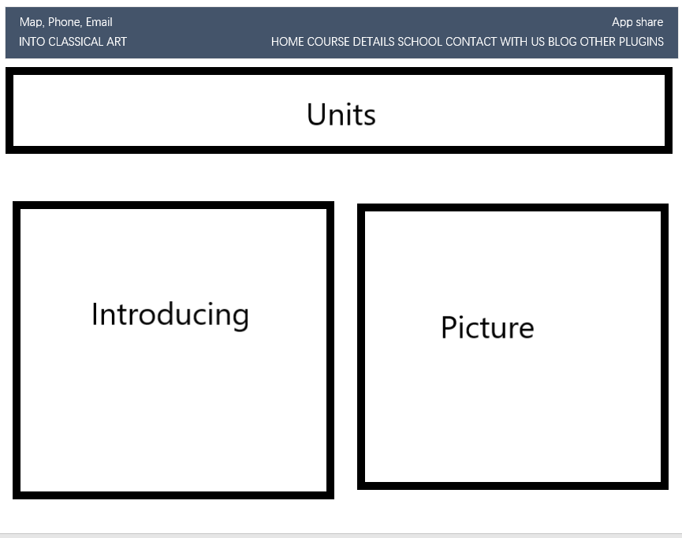

3.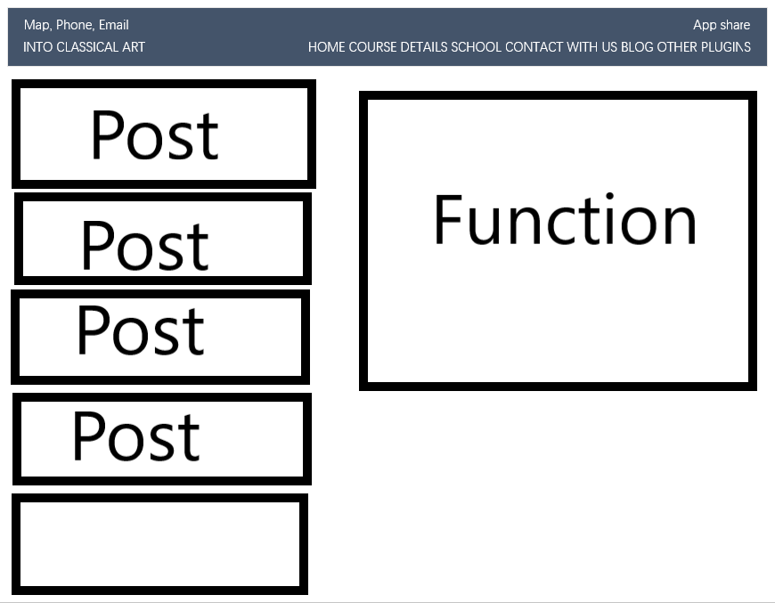 4.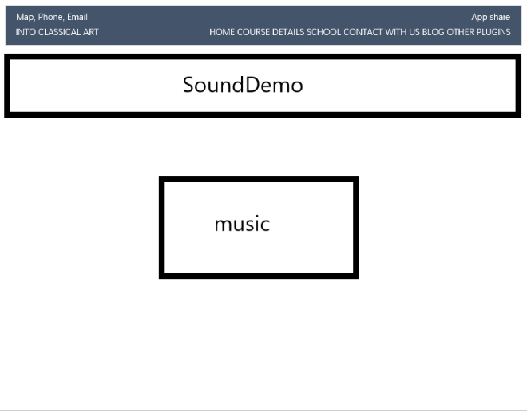5.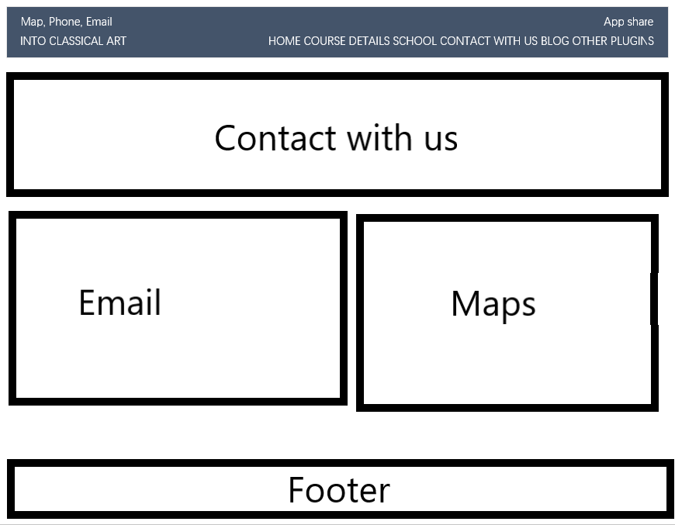

# Purpose

Now that you know who your visitors are, you need to consider why they are coming. While some people will simply chance across your website, most will visit for a specific reason.

Your content and design should be influenced by the goals of your users.

To help determine why people are coming to your website, there are two basic categories of questions you can ask:

1. The first attempts to discover the underlying motivations for why visitors come to the site.

***They visited my website in order to learn more about classical art and improve their knowledge of music and painting.***

1. The second examines the specific goals of the visitors. These are the triggers making them come to the site now.

***They have no way to go through their own in-depth study, so they need a systematic course of study.***

**Key motivations**

* Are they looking for general entertainment or do they need to achieve a specific goal?

***specific goal***

* If there is a specific goal, is it a personal or professional one?

***personal***

* Do they see spending time on this activity as essential or a luxury?

***luxury***

**Specific goals**

* Do they want general information / research (such as background on a topic / company), or are they after something specific (such as a particular fact or information on a product)?

***a particular fact***

* Are they already familiar with the service or product that you offer or do they need to be introduced to it?

***they need to be introduced to it***

* Are they looking for time sensitive information, such as the latest news or updates on a particular topic?

***No***

* Do they want to discover information about a specific product or service to help them decide whether to buy it or not?

***No***

* Do they need to contact you?

***Yes***

# Target of Audience

A target audience is the [demographic of people](https://www.thebalancecareers.com/demographic-data-is-critical-for-media-2315179) most likely to be interested in your product or service. If you own a plumbing company, your target audience is property owners, both commercial and residential. If you own a toy store, your target audience is parents, grandparents, and anyone else with children in their lives. The best place to being is by thinking about the specific needs your product or service fulfils.

Every website should be designed for the target audience—not just for yourself or the site owner. It is therefore very important to understand who your target audience is.

It can be helpful to ask some questions about the people you would expect to be interested in the subject of your site.

If you ask a client who a site is for, it is not uncommon for them to answer "the entire world."

Realistically, it is unlikely to be relevant to everyone. If your site sells light bulbs, even though most people using a computer probably use light bulbs, they are not likely to order them from someone in a different country.

Even if the site has a wide appeal, you can still think about the demographics of a sample of the target audience.